Uploading code to attiny85 using Arduino board
- direct uploading will not work, go to sketch>upload using programmer.
- If upload shows this error then there is error in connection most likely the Reset pin (reset or CS or SS).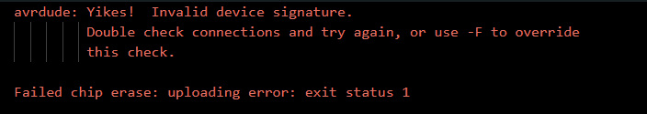

- NB: DO NOT use the reset pin(PCINT5) as a button input or as any output since it may reset the whole IC
- NB: If you want to use any pin as analog input then do not just write "int button = 4" instead write "int button = A2" OTHERWISE IT WILL BE USED AS DIGITAL INPUT
- Upload system for attiny13 and 85 are the same
